Jobs Portal
A MySQL database for a job website where employers post jobs and job seekers apply.
MySQL HTML css JavaScript
IDEA

The problem it solves
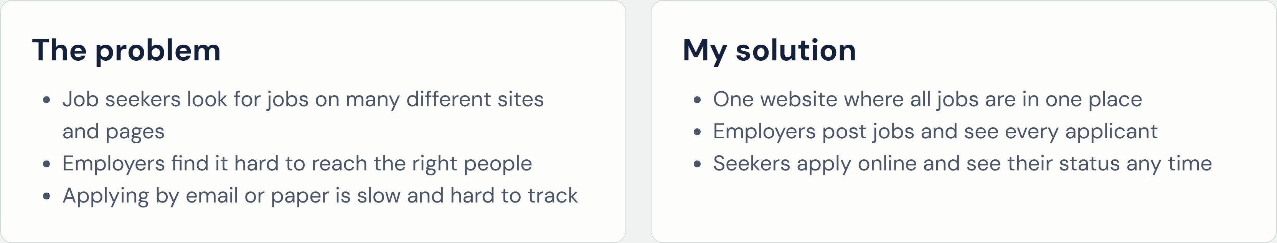
Goal: make finding a job and hiring a person simple, fast and clear.
THE

Three types of users

oo

Job Seeker
- Creates a profile and uploads a CV
- Searches and saves jobs
- Applies and tracks the status

Employer
- Creates a company profile
- Buys a package and posts jobs
- Shortlists and hires applicants

Admin
- Approves new jobs Checks and approves payments
- Manages users and categories

IDEA

How it works in three steps

Job seeker
I Create a free account  Employer |  | 2 the profile and upload a CV |  | 3 Apply and follow the status
Register the company |  | Choose  2 a package and post |  | Shortlist and hire the  3
Fill in
a job best people
IDEA

Finding the right job is easy
Filter by: Category City Job type Experience Salary Remote
 Featured jobs are shown first Save a job and apply later O Old jobs hide after the deadline

REFERENCE WEBSITE

Based on a real job portal
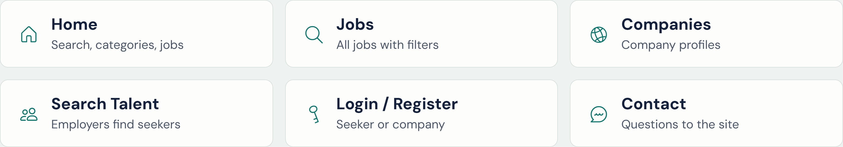
I studied the main pages of a demo job portal, then designed my own simpler database for the same features.
• Reference: Jobs Portal demo, sharjeelanjum.com
DATABASE STRUCTURE

18 tables in 7 groups

Users & profiles | Lookup lists | Seeker CV | Jobs
users | cities | educations | jobs
companies | categories | _ experiences | job _ skills
 | skills | skills

Applying Packages Payments & alerts
job _ applications packages payment _ methods saved _ jobs subscriptions payment _ transactions notifications
1

Users and profiles
Table | What it stores | Linked to
users | Login details of every user: admin, employer or seeker
companies | The company profile of an employer: name, logo, address | users, cities
seekers | The profile of a job seeker: headline, salary, CV file | users, cities, categories
Key idea: everyone logs in from one users table. The role column says who they are, and their details are kept in companies or seekers.

2 3

Lookup lists and the seeker's CV
Table | What it stores | Linked to
cities | Cities with their division | companies, seekers, jobs
categories | Job categories, such as Sales or IT | jobs, seekers
skills | Skill names, such as PHP or Excel | jobs, seekers
seeker educations | Degrees and results of a seeker
 | Past and current jobs of a seeker | seekers
seeker | Which skills each seeker has | seekers, Skills
The first three are lists the admin manages, used in dropdowns. The last three hold the CV details of a seeker.
4 5

Jobs and applications
Table | What it stores | Linked to
jobs | Job posts: title, salary, deadline and status | companies, categories, cities
job _ skills | The skills a job needs | jobs, skills
job _ applications | Each application and its status | jobs, seekers
saved _jobs | Jobs a seeker has bookmarked | jobs, seekers
Application status: applied viewed shortlisted interview hired rejected
6 7

Packages, payments and notifications
Table | What it stores | Linked to
packages | Plans to buy: Free, Standard, Premium
subscriptions | A bought package and the job posts left | users, packages
payment _ methods | Cash, bKash, Nagad, Rocket, Bank, Card
payment _ transactions | Every payment: amount, TrxlD, status | users, subscriptions, payment _ methods
notifications | Messages like "You are shortlisted" | users

RELATIONSHIPS

Three ways the tables connect
One to one | One to many | Many to many
Users companies | companies jobs | jobs skills
Users | jobs job _ applications | via job _ skills
One employer has exactly one | One company can post many jobs. | A job needs many skills, and a skill
company profile. | One job gets many applications. | is used in many jobs. A middle
table joins them.
Tables are joined with a foreign key: a column that stores the id of a row in another table, such as jobs.company_id.
PAYMENT FLOW

How a package is bought

Choose a package
A new row in subscriptions pending
2
Pay and send the TrxlD
A new row in payment _ transactions pending
3
Admin approves
Payment and package both become ready completed active

Each payment is linked to one row in payment _ methods: Cash, bKash, Nagad, Rocket, Bank Transfer or Card.

PROJECT IDEA

Ideas for the future
Email job alerts
Send new matching jobs to seekers by email
Mobile app
Search and apply from an Android or iPhone app
9 Chat
Employers and seekers send messages inside the site
Bangla and English
Let users choose the language of the website

SUMMARY

Simple, linked and safe
tables in 7 groups user roles in one login table payment methods

A seeker can apply to a job only once Q) The same TrxlD cannot be used twice
Passwords are saved as secure hashes Deleting a user also removes their profile
• Thank you

